Key Terms: Know the Definitions
- Apartheid
- Afrikaner
- Genocide
- Darfur
- Refugee
- Scarcity
- Extermination
- Pandemic
- Epidemic
- Environmental Factors

- Where was Apartheid practiced?

- What was the purpose of Apartheid?

- A famous leader of the ANC that would eventually become the first black president of South Africa:

- What are some reasons for genocide?

- Why was genocide breaking out in Darfur?

- What is life like for a refugee?

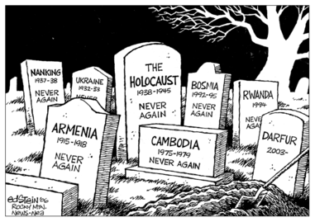

- What is the message the artist is trying to communicate in this cartoon?

Key Terms: Know the Definitions
- Apartheid
- Afrikaner
- Genocide
- Darfur
- Refugee
- Scarcity
- Extermination
- Pandemic
- Epidemic
- Environmental Factors

- Where was Apartheid practiced?

- What was the purpose of Apartheid?

- A famous leader of the ANC that would eventually become the first black president of South Africa:

- What are some reasons for genocide?

- Why was genocide breaking out in Darfur?

- What is life like for a refugee?

- What is the message the artist is trying to communicate in this cartoon?

