By Magda Healey, eHow Contributor - last updated February 05, 2015

The term "economic system" refers to the way in which the decisions about producing goods and services are made within a given society and the rules that govern distribution of those. Who decides what to produce and how? Who owns the resources? How are the produced goods to be allocated to their end users? The economic systems are usually classified into three major types: market economy, command economy and mixed economy.

Market Economy
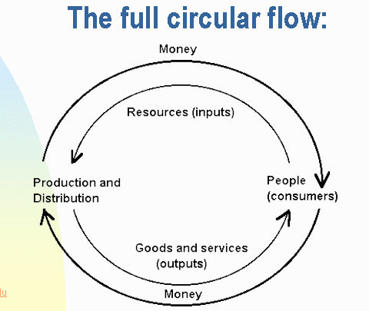
    - In a market economy, supply and demand determines the prices. In a market economy, people’s interests determines what gets sold. An example would be if people demand, and are able to purchase, a television, then the television gets produced. The relationship between demand from the people and the amount of televisions in supply from the companies determines the price of the television. The government doesn't intervene in the running of the economy beyond setting up the basic, large-scale, stable framework for the market to operate in. There are no price controls or economic planning by the government. The government owns no economic resources and is not an active player in the market. Countries that have a market economy are Mexico, Germany, and Canada.

Command Economy
    - In the command, or planned, economy, the decisions of the government drive the production. If the government decides that certain television are to be produced, they get produced. The prices for the televisions are also set centrally by the government. All the economic activity is either controlled by or directly performed by the state (government). The state owns all the economic resources and is either the only or the predominant player in the market. Iran, Cuba, China and North Korea have command economies.

Mixed Economy
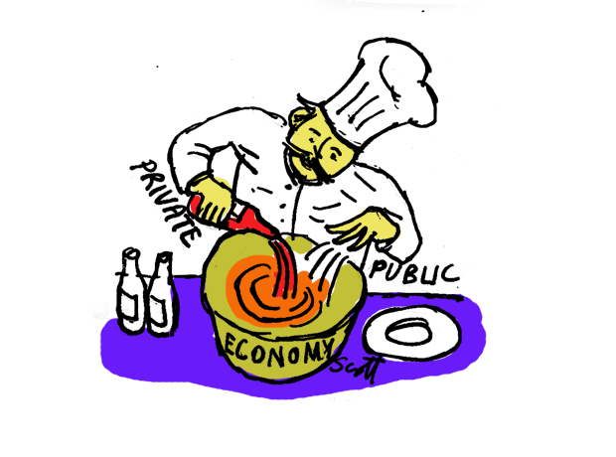
    - While both market economy and command economy are somewhat idealized models, in reality, most national economies are mixed economies. Some lean more toward the market model, and others toward the command model. But, all mixed economies have elements of both. There is a private or market sector, where the private-ownership, supply-and-demand and profit-motive rules of the market economy apply. But, the government intervenes in the running of this sector by enforcing rules and often price controls and subsidies (financial assistance) for certain industries or specific businesses. In a mixed model, the state is also often a player in the market. The public sector can comprise a large amount of the economy, often in crucial areas such as the military, law enforcement, road and transport infrastructure (buses & trains), education or health services. The state can be a producer/supplier, for example in the case of health, education or nationalized public utilities (gas, electric, or water), media or transport companies. The state (government) can be also a buyer, for example for private providers of health services, or producers of steel and concrete used for roads and bridges, and often both, as can be the case when the government buys weapons from a nationalized weapons producer. Countries with a mixed economy include Iceland, Sweden, France, the United Kingdom, the United States, Russia and China.

Advantages and Disadvantages
    - The market system is generally runs smoother, faster to react to changing environments and thus more responsive. It allows individuals to express initiative and allows for new ideas. However, large-scale market economies tend to be dangerous, and lead to concentration of capital (money) and thus social inequalities (The rich get richer while poor stay poor). The movement of limited resources might not be socially advantageous, and the pursuit of profits (more money) above all can lead to unacceptable social consequences, for example by allowing dangerous products to be sold or creating environmental pollution. Command economies can be slower, and central planning can be slow to respond to changing environments. Individual initiative and creativity can be hampered and often a class of powerful bureaucrats (politicians/government workers) develops. Most successful economies nowadays combine elements of the command and market systems in an attempt to balance the advantages and disadvantages of both.

