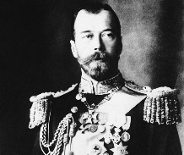
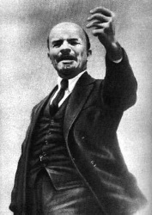
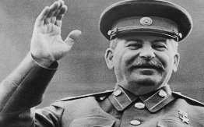
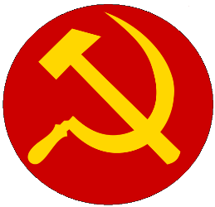
- Russian Government Before Russia
  - Monarchy: __________ (_____)
  - Until 1905 the Tsar's powers were _____________.
  - Russia had no ________________ and no ___________ ____________ _____________ to check the Tsar's power.
  - A strong ____________ ____________ which terrorized the people.
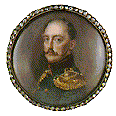
  - Royal Background
    - Nicholas II
      - Created the first __________ _________ in Russia, brutal leader, response to revolt of army officers in ______
    - Alexander II
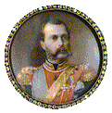
      - He implemented important _________, notably the abolition of __________
Abolition = To get rid of
      - In ______, he sold Alaska and the Aleutian Islands to the United States.
      - Killed by the Revolutionary Group: The People’s ______
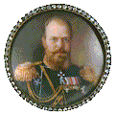
    - Alexander III
      - Alexander III's reign was during an _____________ _____________ in Russia.
      - His reign was _________, against revolutionaries and other liberal movements.

- Czar Nicholas II (1894): Last Czar of Russia
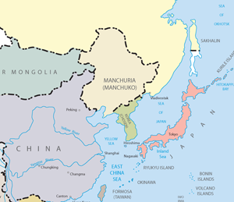
  - Nicholas II was a ________ and ________ ruler
Russia
  - The Russian economy was bankrupt because of the Russo-Japanese War and WWI Russia’s entry into WWI became very unpopular.
Manchuria
  - ________-____________ War (1904)
Japan
    - Dispute over _______________ with _________
    - Shook national confidence in their progress and rule of Czar.
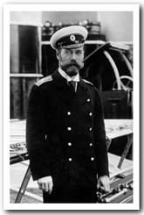
  - Bloody Sunday (1905)
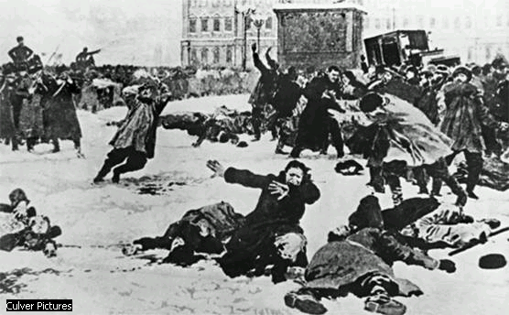
  - Russia and World War I
    - Russia declares war on _________-____________
    - War becomes unpopular
    - Rationing leads to ______________
    - Nicholas II leaves St. Petersburg to war front
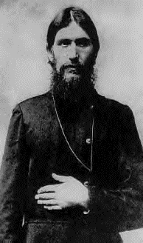
  - Rasputin
    - An advisor to Czarina Alexandra (wife of Nicholas)
    - Caused lots of drama in family
    - Multiple assassination attempts

- Revolutions
  - March Revolution (1917)
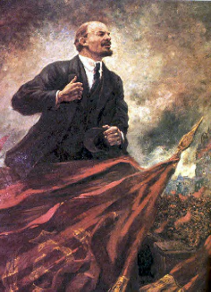
    - ________- Protests spread through ________________ and the Royal palace is taken over.
    - Czar _________________
    - Provisional government (________) takes control lead by Alexander Kerensky
    - Provisional government unpopular after decision to stay in ____
  - October (Bolshevik) Revolution-1917
    - Lead by ____ ________ “Peace, ________, and __________”
    - Won support of people (especially peasants)
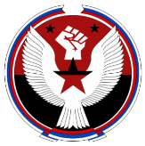
  - 1918
    - ________ March - The ______________ accept the peace of Brest-Litovsk, ending WWI with _______________.
  - 1919-1920
VS
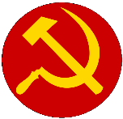
    - 1919 ___________ Armies (Royal and _______________ troops) attack the __________ (_____________) from all directions.
    - 1920- Reds defeat Whites

- Rule of Lenin 1920-1924
  - ______________ ___________ included the New Economic Plan (NEP)
    - Moderate mix of ______________ and _______________
  - Political Reforms
    - Bolshevik party became ________________ Party
    - Russia becomes the ___________ Soviet Socialist ____________
  - Communism
    - A Form of ______________
      - ____________ ______________ of the Economy by the State
    - _________(Communist Party) makes decisions on _____________ jobs and pay
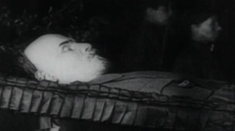
- 1924
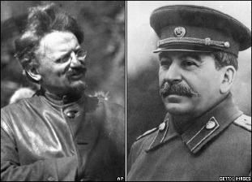
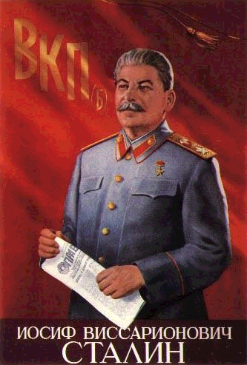
  - ___________ Dies
  - Power Vacuum
  - ___________________ vs. ____________________
  - Stalin takes control
  - Now must decide how he will maintain power
  - Decides to create a ______________________ state

- Characteristics of a Totalitarian State
  - ___________________- Absolute Authority
  - Dynamic Leader- Vision for the nation
  - __________ ____________ Over All Sectors of Society
    - Business, Family Life, Labor, youth groups, housing, religion, education, the arts
  - State Control Over the _______________
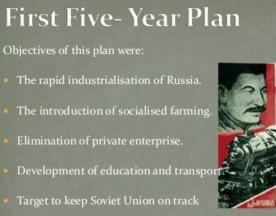
    - Obedience
    - Denies basic liberties
  - Organized ___________________
    - Uses force to crush opposition

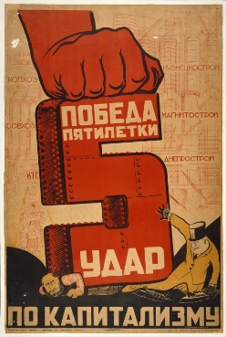
- Stalin’s Totalitarian State
  - State Control of the Economy
    - __________ plan, collective farms
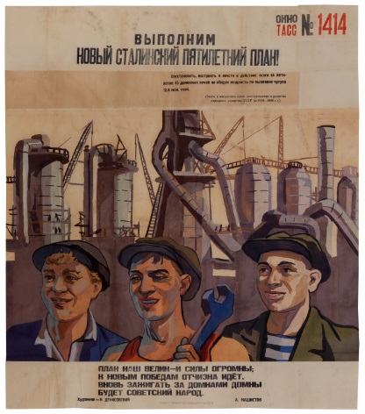
  - Police Terror
    - __________ __________, crush opposition
  - Religious Persecution
    - Control of the ________________
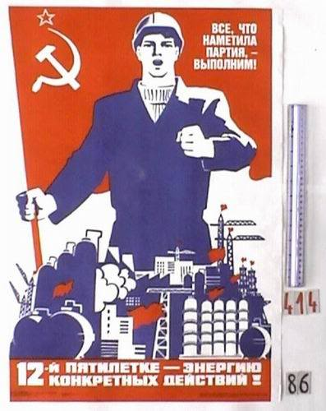
  - __________________ (socialist realism)
    - Molding peoples’ minds
  - Education
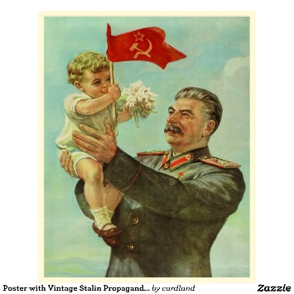
    - Controlled by the government

