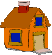
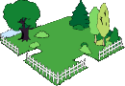
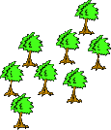
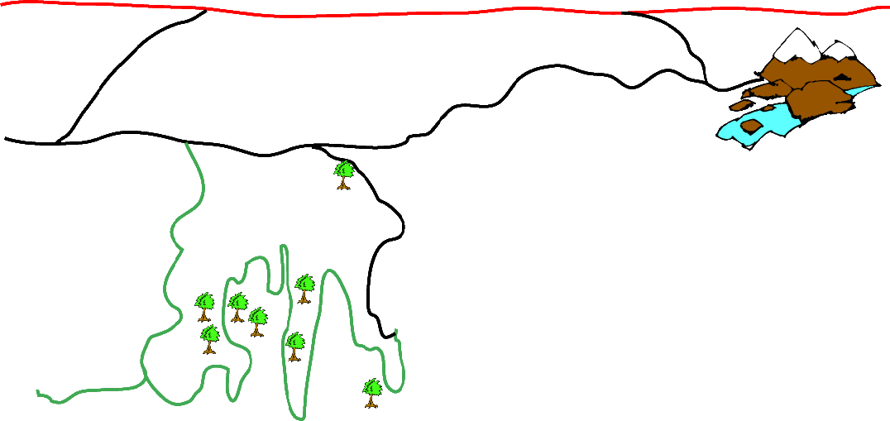
1. If you take County Road from the house to the church, about how many miles would
you travel to get there?
2. Which road gives you the shortest distance from the house to the park?

3. Which direction would you travel going from the house to the church?

4. What would be the fastest way to get from the house to the mountains?

5. About how many miles is it from the park to the mountains?

6. Which direction would you travel going from the mountains to the house?

7. According to this map, what is the only reason you would want to take the highway

