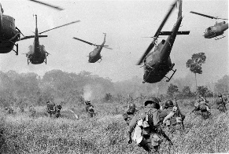
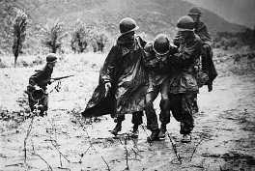
Korean War
- First “________________” of the Cold War. From ________________.
During WWII
- The ___________ decided to divide Korea at the _______ Parallel.
  - The _________ was under the trusteeship of the _______.
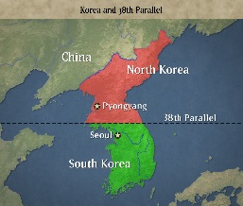
  - The _________ was under the trusteeship of the _______.
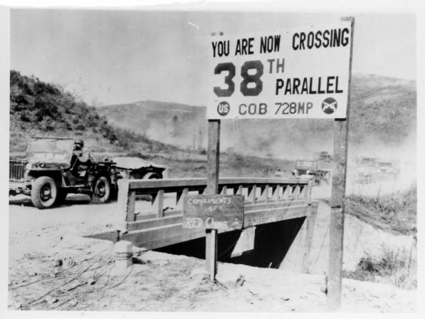
- This led to the rise of two separate nations:
  - North Korea = _______________
  - South Korea = _______________
Rise of Tensions
- Both sides wanted to _____________, but wanted to reunite under _______________ political belief.
The Start of War
- In ________, after a few skirmishes at the border, ______ broke out.
  - The _________ supported and fought for the __________.
  - __________ supported and fought for the __________.
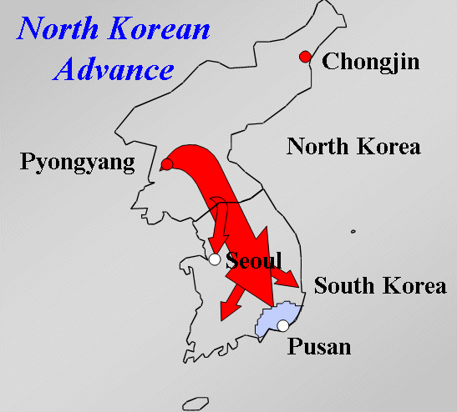
Successes & Failures
- Initially, the ____________________ forces pushed deep into _______________.
- But, after ___________ entered the war, ______________ forces were pushed back into the ________.
Armistice
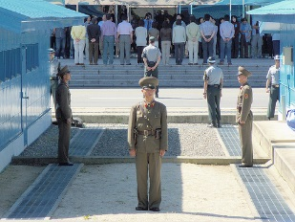
- After _____________, the two sides fought to a stalemate.
- The countries remained split, divided at the 38th parallel.

Vietnam War
- Second “____________” of the Cold War. From _______________
French Colony
- _______________ was once a French colony.
  - _____________ could no longer look over the land.
- After leaving, communist countries of ________ & _________ recognize the Democratic Republic of _____________ as the official government.
  - The _____________/_____________ would be the pro-communist fighters throughout; Led by __________________.
Conflict Rises
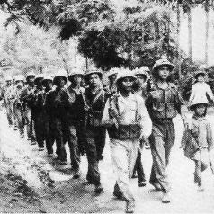
- Northern ______________ supports, backed by __________ and __________ move forward into the south
- The ________ eventually provides support for the _________, and later sends in troops.
  - Official start for the ________ military was the ______ of ________
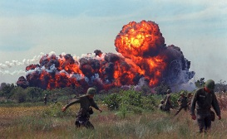
Key Battles
- ____________ ; _______________ ; ________________
- _____________ were successful in _____________ style warfare.
- _____________ also used a vast __________________ to move soldiers and supplies.
U.S. Exits
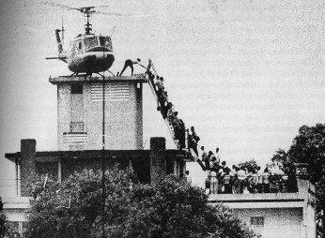
- After many casualties and failed attempts, the last troops leave ____________ on ________________.
  - North ___________________ would enter the city the next day
  - Vietnam would become _____________ throughout the whole country.

