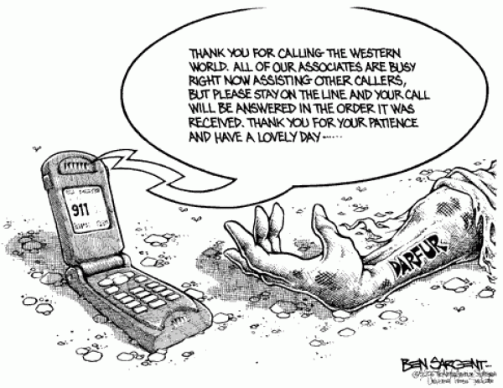
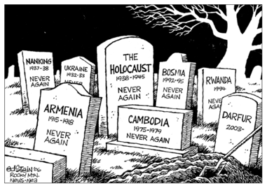
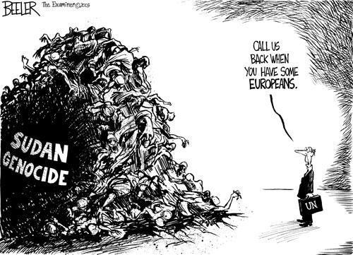
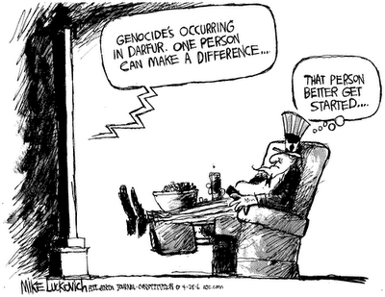
- 2)

3) 4)

Cartoon 1
- What images are being portrayed in the cartoon?

- What is the significance of the headstones?

- What lesson can we take away from this image?

Cartoon 2
- What images are being portrayed in the cartoon? What do they represent?

- What is the significance of the operator’s message?

- What do you think the cartoon is suggesting?

Cartoon 3
- What images are being portrayed in the cartoon?

- What does the cartoon think is being done in Darfur?

Cartoon 4
- What images are being portrayed in the cartoon?

- What message is the artist saying about how Darfur is being handled?

