Adidas
Boycott call from Viva for using kangaroo skin to make some types of football boots.
Adidas are phasing out the use of kangaroo leather by 98 per cent over 12 months but will still use small amounts of it so the boycott continues.
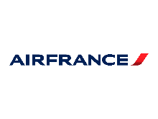

Air France
Air France is the only major airline that continues to ship monkeys to laboratories for experimentation. Primates transported by Air France are frequently be taken from the wild, and were transported on journeys that could last for more than 30 hours. Once transported, the primates’ experience only darkened.

Amazon
We have called a boycott of Amazon over their outrageous tax avoidance.
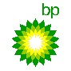

BP
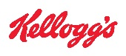
The company has come in for a boycott call thanks to one of the worst environmental disasters ever to befall the United States, the Deepwater Horizon oil spill in the Gulf of Mexico.

Kellogg’s

For using sugar from genetically engineered sugar beets in its products

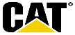
Caterpillar
Some have called for a boycott of Caterpillar for selling bulldozers to Israel in full knowledge that they will be armored and used to destroy Palestinian homes, infrastructure and agriculture in the Occupied Palestinian Territories.

FedEx
Some have called for a boycott of FedEx for as long as they continue to sponsor the Washington Redskins - who bear a racially offensive name.

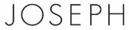
Joseph Ltd.
This company is under a boycott call from Campaign Against the Fur Trade for selling coats and other products made from animal fur and boots made from rabbit fur.

L’Oreal
Naturewatch has a long-standing boycott of L'Oreal due to its continued use of animal testing for cosmetics. The French multinational uses ingredients that have been tested on animals, despite public statements to the contrary.

Nokia/Siemens
The company provided the Iranian regime with a "monitoring center" that enables security forces to tap cell phones, scramble text-messages, and interrupt calls. Nokia's new surveillance system has enhanced the regime's ability to crack down on dissent during recent protests.
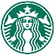

Starbucks
Starbucks is under a boycott call from the Industrial Workers of the World and US Organic Consumer's Association over its treatment of Ethiopian coffee farmers.

Gap
After the horrific Rana Plaza factory collapse in Bangladesh, Gap was one of numerous companies to reject a proposal for better oversight over working conditions at overseas factories—and given the company’s history of past involvement with child labor and other worker abuses, it didn’t sit well.

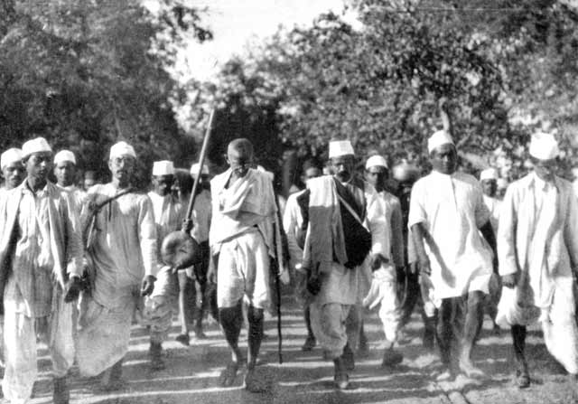
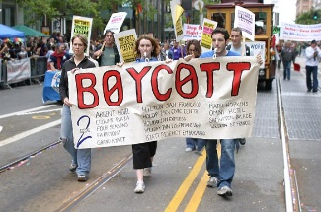
Gandhi: Protests and Boycotts
A boycott is a withdrawal from commercial or social relations as a punishment. Gandhi and his supporters helped changed India through their use of boycotts. Gandhi led the Salt March, in 1930, because the British government had tight control on the salt trade and taxed it very heavily. Gandhi also promoted boycotting other British goods like cloth and food. He was an advocate for making one’s own cloth and growing one’s own food. He believed that if enough people showed they did not need to rely on Great Britain, then the British government would grant India its independence. By 1947 those efforts proved to be successful, as India gained her independence.
Today, you will create a plan of action to protest/boycott a modern company. gYou will complete the following:
- Choose a company to boycott (Companies have been provided to save time): ______________________________________________________________

- Provide a brief summary to why the company should be boycotted: __________________________________________________________________________________________________________________________________________________________________________________________.

- Create a catchy slogan to get the public’s attention to your cause: ____________________________________________________________________________________________________________________________.

- Brainstorm an idea for a demonstration to continue your protest (like
Gandhi’s Salt March): ______________________________________________________________________________________________________________________________________________________________________________________________________________________________________________________________________________________________________________________.
Example:
- Choose a company to boycott: Walmart

- Provide a brief summary to why the company should be boycotted: Walmart low wages and little to no insurance benefits for their employees, meanwhile the company sees record profits each year.

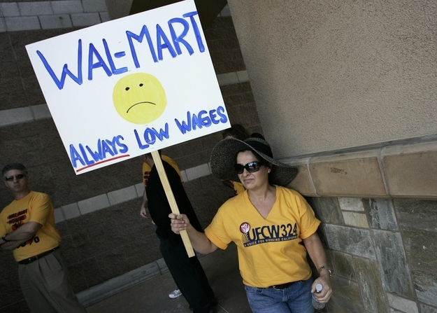
- Create a catchy slogan to get the public’s attention to your cause:

- Brainstorm an idea for a demonstration to continue your protest:
We will hold a protest by burning our name badges, to show how we no longer want to be connected to a company that does not take care of their employees.

Examp
dfkdkdkd

