Percentage of Adults with AIDS
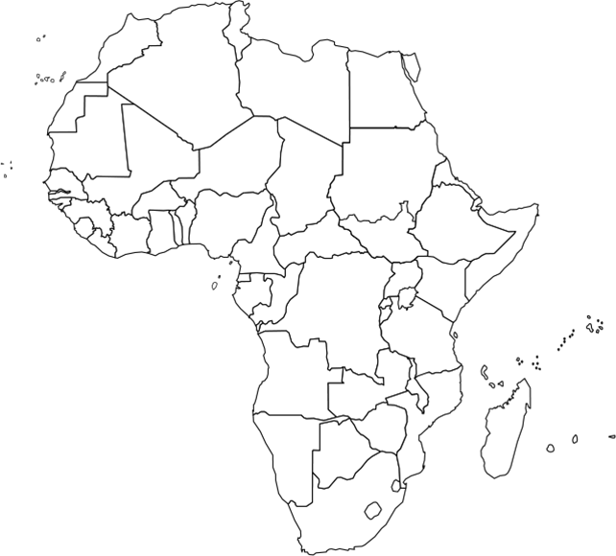

Per Capita Income Illiteracy Percentage

NAME:
- Color or Key the following countries in Africa to show the percent of men and women infected with HIV/AIDS: South Africa, Kenya, Uganda, Botswana, Sudan, Tanzania, Zimbabwe, Zambia, Malawi, and Nigeria.
    - Each color/key should represent one of the following groups:
    - 0–1% 1–10% 11–20% 21–30% 31–40% 40%+

- Color or Key the following countries in Africa to show the per capita income (how much money each person makes in a year): South Africa, Kenya, Uganda, Botswana, Sudan, Tanzania, Zimbabwe, Zambia, Malawi, and Nigeria.
    - Each color/key should represent one of the following groups:
    - $0-500 $501-1000 $1001-1500 $1501-2000 $2001-2500 $2501-3000 $3000+

- Color or Key the following countries in Africa to show the illiteracy rate of each country: South Africa, Kenya, Uganda, Botswana, Sudan, Tanzania, Zimbabwe, Zambia, Malawi, and Nigeria. ***To get the illiteracy rate from the literacy rate, subtract the literacy rate from 100%.
    - Each color/Key should represent one of the following groups:
    - 0-10% illiterate 10-30% illiterate 30-50% illiterate 50%+ illiterate

Answer the questions below based on your completed maps.
4. Which three countries (of the ten you surveyed) had the highest percentage of HIV infected people?
5. Which three countries (of the ten you surveyed) had the lowest income?
6. Which three countries (of the ten you surveyed) had the highest literacy rate?
7. Do you see any correlations between HIV infection, poverty and/or the ability to read? In other words, were the countries with high illiteracy and low per capita incomes more likely to have high HIV infection rates?
8. If you see correlations, explain why such correlations might exist. If you don’t see any correlations, explain why that is the case.
9. Explain why it might be helpful to know the rate of literacy and poverty among people likely to contract HIV.

