European Monarchs
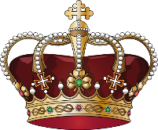
European monarchs were creating powerful kingdoms where everyone had to answer to the king/queen
• Absolutism: ____________________________________________________________
_______________________________________________________________________.
• Divine Right: ___________________________________________________________.
• Goal: _________________________________________________________________.

Age of Absolutism (1500-1700)

Hapsburgs: _____________________________________________________________.
• Lands scattered so: –Ferdinand (Charles V brother)
• Holy Roman Emperor, controlled central Europe (today Germany) –Philip II (Charles V
son)
• Controlled Spain, the Netherlands, and overseas empires

Spain (1500-1700)
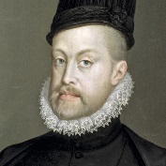
Philip II: ________________________________________________________________.
– Most powerful monarch in Spanish history
– Saw__________________________________________________________________.
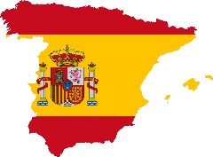
• Enemy of all protestant countries

– Caused _______________________________________________________________.
– 1567: ________________________________________________________________.
• Protestant ______________________________________________________.

Last of the Spanish Hapburgs

After __________________________________________________________________.
Economy ______________________________________________________________.
• Still received a lot of gold from its colonies, but spent more than it received
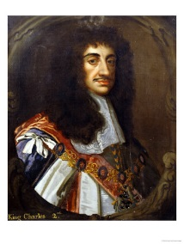
• Inflation grew and industry and agriculture declined
• Kicked out Muslims and Jews—for religious reasons—they were the skilled merchants
and artisans
• Series of corrupt and incompetent leaders
• Overtaxed its citizens and much of the empire rebelled
Charles II _______________________________________________________________.

England

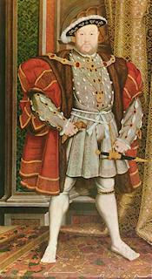
Tudor ________________________________________________________.
– Not _________________________________________________(___________)
• Henry VII: first Tudor - took control after War of the Roses
• Henry VIII: second Tudor to reign - most powerful Tudor ruler
• Turmoil after Henry VIII died:
– Edward VI: Young and short reign
– Mary I: Catholic, “Bloody Mary”
• Married Philip II of Spain, Burned Protestants at the stake, died
childless
– Elizabeth I:___________________________________________________.

Elizabeth I:
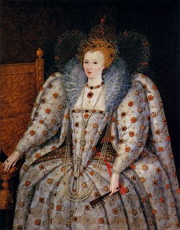
– Very ____________________________________________________________________.
– Her _____________________________________________________________________.
• She ___________________________________________________________
___________________________________________________________.
– During Elizabeth’s reign she set up a hierarchy of social rank in English society

Spanish Armada

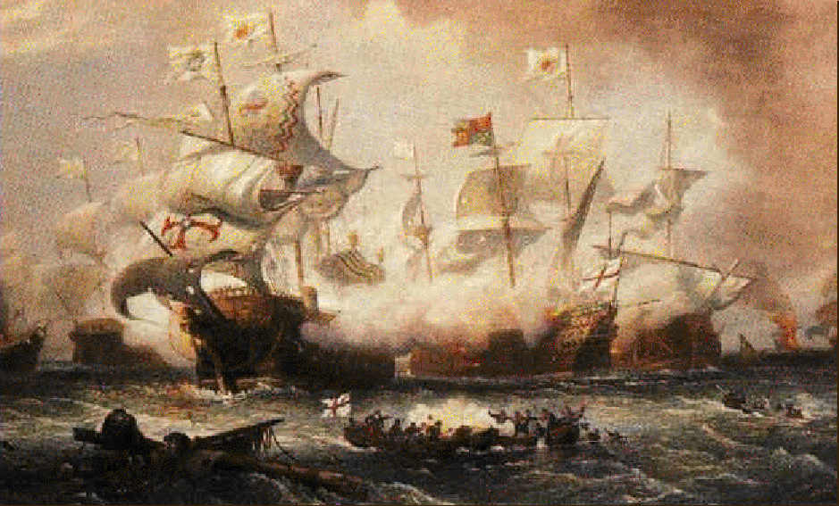
• Reasons Spain attacked England:
– England________________________________________________________.
– England ________________________________________________________.
– England supported pirate raids on Spanish ships
• 1588 ________________________________________________________________.

•Armada got “stuck” in the English Channel
• Spanish crescent formation difficult to defeat
• English _______________________________________________________________.
• English use fire ships to destroy the Spanish formation
• Severe weather destroyed remainder of fleet during retreat
• Defeat _______________________________________________________________.

